5E Lesson 3 Gummy Worm Lab- Science
Name: Jeanette Fehr |  | Date: July 16, 2011
Content Area: Earth Sci. | Grade Level(s): 9+ | Topic(s): Experimental Design  Using the Scientific Method

Standards (SOL)

Earth Science SOL Standard
ES.1a,c,e
ES.2b,c,d

Objectives (UKD’s)

Students should be able to:
- Plan, conduct, and write-up a scientific investigation using experimental design
- Collect measurement data (mass, volume, density, using the most appropriate tools)

Materials & Resources

- Gummy Worm PowerPoint
- 2-pound container of Gummy Worms (they may be cut in half)—may want to provide a couple extra per group for student consumption)
- Metric rulers (at least 1 per seat/shoulder partner/shoulder)
- At least 4 balances (based on availability)
- Calculator (option)
- Plastic Petri dishes (either 1 per child or 1 per seat partner) or plastic cups
- Grease pencil
- Cold or Ice Water (Ice can be acquired from the cafeteria or athletic department)
- Sink & counter space
- Paper towels
- General Directions —See: Word Document Gummy Worm Lab_General Directions (only one is needed per group)
- Worksheet—See Word Document Gummy Worm Lab_Experimental Design Guide
- Computers (optional) some students may prefer to type the experimental design for the extension

http://www.bing.com/images/search?q=gummy+worm&view=detail&id=9B47EF51863675919D9612DEE1AFCAD7CD744B85&first=0 Retrieved July 16, 2011

http://www.pantryspa.com/wp-content/uploads/2009/07/gummyWorm.jpg Retrieved July 16, 2011

http://www.ssdan.net/datacounts/images/bargraph.gif Retrieved July 16, 2011

T. Trimpe 2002. Retrieved July 16, 2011 from
http://sciencespot.net/Media/mmaniabearlab.pdf

* This had been modified from the original Gummy Bear Lab to Gummy Worm Lab for more accurate measurements. Gummy bears didn’t seem to last two days on the rotating block schedule system. Worms have a better chance in Petri dishes.

Safety Considerations
*This activity should not take the whole class; once measurements are gathered, the gummy worm is placed in its Petri dish and set on the counter top, and the lab is cleaned up, the teacher can move-on to another lesson.

- Student should refrain from eating any gummy worms used in the experiment. Balances should be used gently, placed on a level countertop, zeroed, and always reset before the next use. (Common mistake: straddling the balance over countertop seams.)
- Caution should be used if water spillage occurs on the floor; have towels or paper towels available.
- During the extension phase of the lab exploration, students select a new independent variable. Teachers want to “approve” the IV and make sure it can be done safely. (Ex: Gummy worms exposed to HCl would need more safety precautions and higher supervision.)
- Students Food allergies or sensitivities to ingredients listed on the package of gummy worms—discuss with student privately to determine an alternate activity. (Grow Capsules can be found at the Dollar Store or General –cheap & handy…18-pack for $1.00. Magic Grow animals cost ~ $1.00 also—sold in singles, but more water is needed and a larger container –like a beaker must be provided because they can expand ~600%.

Engage – Time Estimate 5+ minutes

- Set a plastic cup of several gummy worms between each pair of students. As a warm-up or bell ringer, tell the students that they will be conducting an experiment using some of the worms in the cup. They should list questions about what they ‘can do to the worms’—what would happen if…? Students should pair-share ideas with seat partner or shoulder buddy.
- To gather a set of class data, everyone will begin with the same general lab. (Students can be asked to work individually alongside their partner or they can work in pairs with 1 gummy worm.)
- Extra gummy worms can be consumed

Explore – Time Estimate 25 minutes

- Students should read over the Gummy Worm Lab—General Directions prior to beginning with their seat/shoulder buddy.
- Using the above sheet, each student should answer the question on the lines provided on the Gummy Worm Lab_Experimental Design Guide (worksheet). Suggest to the students that they focus on the process and answers are legible & clearly understood. Their work may help them with the next lab that design on their own.
Title:
Problem:
Hypothesis:
Independent Variable
Dependent Variable
Constants
Control
Procedure: List procedures for part A
Complete Data Chart for Day 1
Procedure: List procedures for part B
Complete Data Chart for Day 2
Conclusion

Explain -- Time Estimate 5+ minutes

Teachers observe the students as they use the measurement equipment making sure that they are measuring in metric and using equipment correctly.
Students may need a little assistance reading the triple beam balance or the dial-a-gram balance.
Students will not only write a conclusion statement, they shall answer follow-up questions following the lab. They should also have a chance to pair-share with their seat partner to discuss what happened in their experiment, why it happened, and were the results similar.
Extend -- Time Estimate 10-15 minutes

Following a teacher guided lab, the students can be encouraged to alter the independent variable. Students may inquiry about: water exposure length of time, different temperature of water, salinity, amount of water, color of worm…)
Students should repeat the experiment with a different independent variable. They should be permitted to write or type the new experimental design using the independent variable (approved by the teacher).
The students will probably not need as much time as their first experiment; they should be more familiar with the equipment and be more comfortable with the process of experimental design. They should be permitted to use the experimental design guide to refer to the process.

Evaluate -- Time Estimate 15-20 minutes

Teachers observe the students’ proper use of lab equipment, review the data collected and assess the calculations. Students should be asked to submit both the Gummy Worm Lab_Experimental Design Guide (worksheet) and their new Experimental Design together once completed. The design and details of new experimental design, answers given in the follow-up questions, and the conclusion summary help determine if students understand the process.

Plans for Diversity

Students at different levels of understanding how to write an experimental design: the activity is developed for both ‘ready-to-design’ students as well as those who need a more teacher-guided approach.
Students who have a stronger understanding of the experimental design process may be pair with those students with a weaker understanding, students who are easily frustrated, or who may have an attention deficiency.
Students stronger with scientific terminology and vocabulary usage may be pair with students with lower reading skills or ELL students.
Students Food allergies or cultural sensitivities to ingredients listed on the package of gummy worms—discuss with student privately to determine an alternate activity. (Grow Capsules can be found at the Dollar Store or General –cheap & handy…18-pack for $1.00. Magic Grow animals cost ~ $1.00 also—sold in singles, but more water is needed and a larger container –like a beaker must be provided because they can expand ~600%.

Connections

Students can build upon this lesson activity as early as the next class. The class data can be filled-in and averaged on the board through a projected chart. Eager-to-please math-inclined students may be asked to calculate averages, but suggest the rest of the class to double check the data.
Students can be asked to develop and label a double bar graph from the class data. The average percent of change between day 1 and day 2 data can be graphed for each of the measurements. If students graph their own percent data change, they can compare, contrast and analyze the class data against their own outcome.
This experiment relates to the scope and sequence of the course pertaining to planning and conducting investigations. Because the inquiry and investigation should be woven throughout the course, this provides a guided practice with the opportunity to quickly reinforce that each student can develop an experiment using the experimental design.

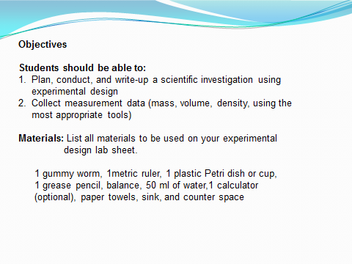
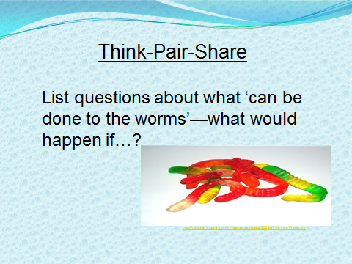
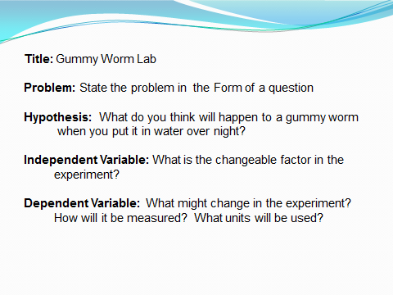
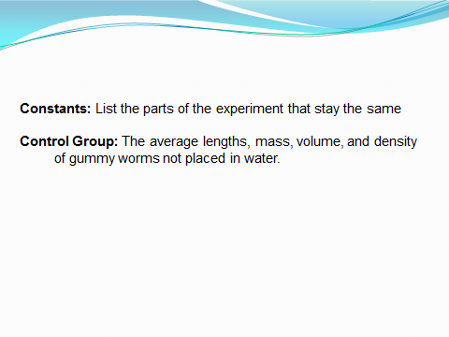
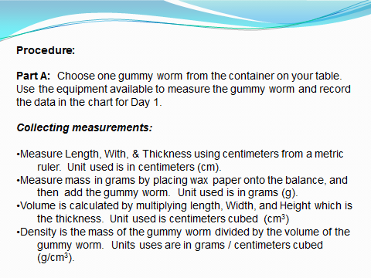
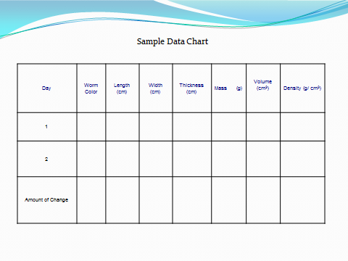
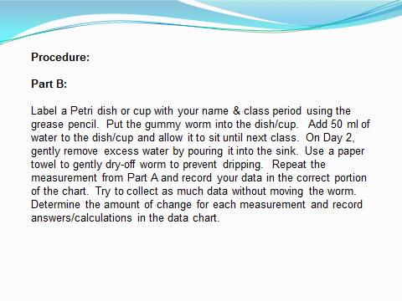
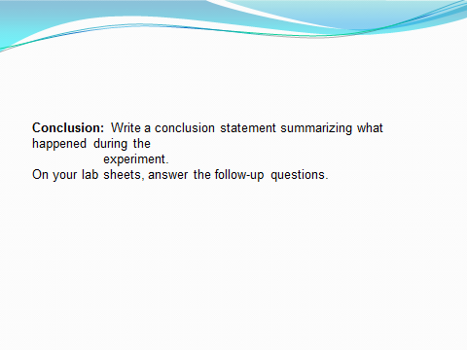
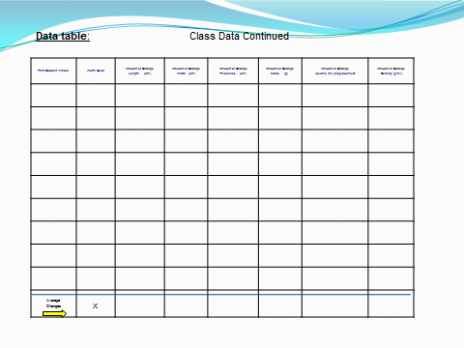
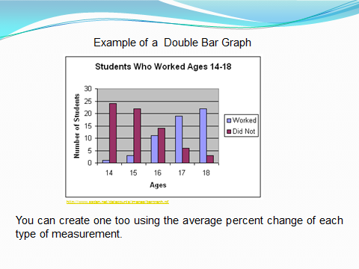
Name ______________________________________________ Period _______

Experimental Design Guide

Title: ____________________________________________________________________

Problem: _________________________________________________________________

Hypothesis: _______________________________________________________________
________________________________________________________________
Independent Variable (IV) : ____________________________________________________
Dependent Variables (DV) : ____________________________________________________
________________________________________________________________
Constants: _________________________________________________________________
_________________________________________________________________

Control Group: ______________________________________________________________
______________________________________________________________

Procedures : List Part A: ________________________________________________________
_______________________________________________________________________
_______________________________________________________________________
_______________________________________________________________________
_______________________________________________________________________
_______________________________________________________________________

List Part B:________________________________________________________

_______________________________________________________________________
_______________________________________________________________________
_______________________________________________________________________
_______________________________________________________________________
_______________________________________________________________________

Conclusion: _____________________________________________________________

_____________________________________________________________

_____________________________________________________________

Data table:

Example Data Table: Each experiment should have at least 15 trials.
Each of your classmates will count as a trial

Day | Worm Color | Length (cm) | Width (cm) | Thickness (cm) | Mass (g) | Volume (ml) displacement | Density (g/ml)
1

2

Amount of Change

Follow-up Questions:

- Was your hypothesis supported? ______________ Why or why not? _________________ ______________________________________________________________________________________________________________________________________________________

- Which change is greater—volume or mass? _________________ Explain: _______________
______________________________________________________________________________
______________________________________________________________________________

- Was there a change in density? ___________________ Why? ________________________
______________________________________________________________________________

- How do your results compare to those of your classmates? ___________________________
______________________________________________________________________________
_____________________________________________________________________________

Data table: Class Data

Print Student Initials | Worm Color | Amount of Change  Length (cm) | Amount of Change  Width (cm) | Amount of Change  Thickness (cm) | Amount of Change  Mass (g) | Amount of Change  Volume (ml) displacement | Amount of Change  Density (g/ml)
Data table: Class Data Continued

Print Student Initials | Worm Color | Amount of Change  Length (cm) | Amount of Change  Width (cm) | Amount of Change  Thickness (cm) | Amount of Change  Mass (g) | Amount of Change  Volume (ml) displacement | Amount of Change  Density (g/ml)

Data table: Class Data Continued

Print Student Initials | Worm Color | Amount of Change  Length (cm) | Amount of Change  Width (cm) | Amount of Change  Thickness (cm) | Amount of Change  Mass (g) | Amount of Change  Volume (ml) displacement | Amount of Change  Density (g/ml)
Average  Changes | X

Gummy Worm Lab-General Directions

Objectives
Students should be able to:
- Plan, conduct, and write-up a scientific investigation using experimental design
- Collect measurement data (mass, volume, density, using the most appropriate tools)

Materials: List all materials to be used on your experimental design lab sheet.
1 gummy worm, 1metric ruler, 1 plastic Petri dish or cup, 1 grease pencil, balance,
50 ml of water,1 calculator (optional), paper towels, sink, and counter space

Title: See the top of this sheet

Problem: State the problem in the Form of a question

Hypothesis: What do you think will happen to a gummy worm when you put it in water
over night?
Independent Variable: What is the changeable factor in the experiment?

Dependent Variable: What might change in the experiment? How will it be measured?
What units will be used?

Constants: List the parts of the experiment that stay the same

Control Group: The average lengths, mass, volume, and density of gummy worms not
placed in water.

Procedure:
Part A: Choose one gummy worm from the container on your table. Use the
equipment available to measure the gummy worm and record the data in the
chart for Day 1.

Collecting measurements:

- Measure Length, With, & Thickness using centimeters from a metric ruler
Unit used is in centimeters (cm).
- Measure mass in grams by placing wax paper onto the balance, and then add the gummy worm. Unit used is in grams (g).
- Volume is calculated by multiplying length, Width, and Height which is the thickness. Unit used is centimeters cubed (cm³)
Density is the mass of the gummy worm divided by the volume of the gummy worm. Units uses are in grams/ centimeters cubed (g/cm³).

Part B: Label a Petri dish or cup with your name & class period using the grease pencil. Put the gummy worm into the dish/cup. Add 50 ml of water to the dish/cup and allow it to sit until next class. On Day 2, gently remove excess water by pouring it into the sink. Use a paper towel to gently dry-off worm to prevent dripping. Repeat the measurement from Part A and record your data in the correct portion of the chart. Try to collect as much data without moving the worm. Determine the amount of change for each measurement and record answers/calculations in the data chart.

Sample Data Chart

Day | Worm Color | Length (cm) | Width (cm) | Thickness (cm) | Volume (cm³) | Mass (g) | Density (g/ cm³)
1
2
Amount of Change

Conclusion: Write a conclusion statement summarizing what happened during the
experiment.

On your lab sheets, answer the follow-up questions.

